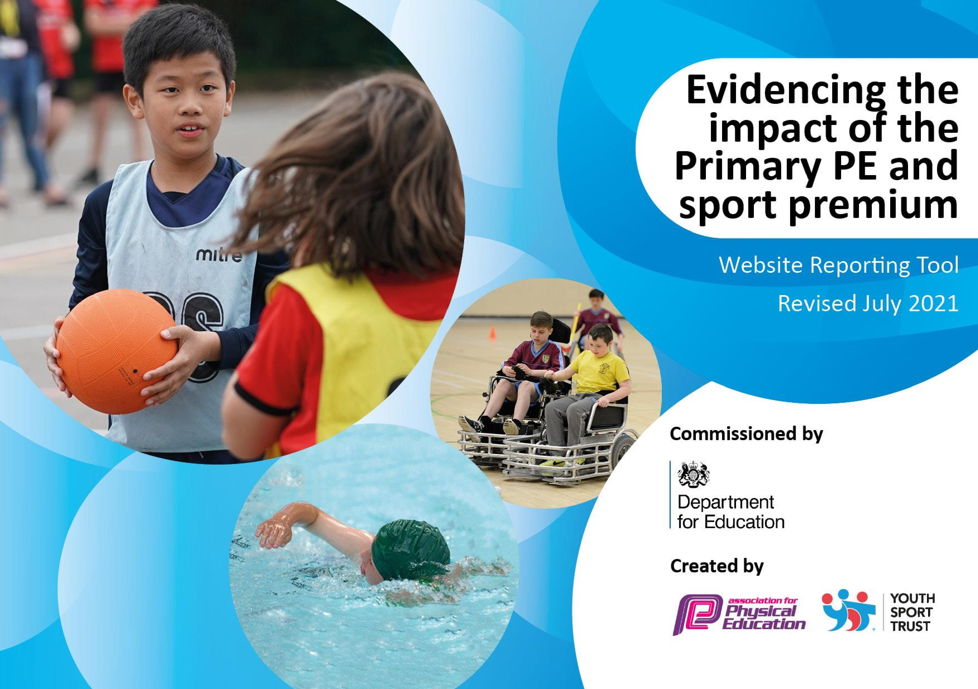
July 23

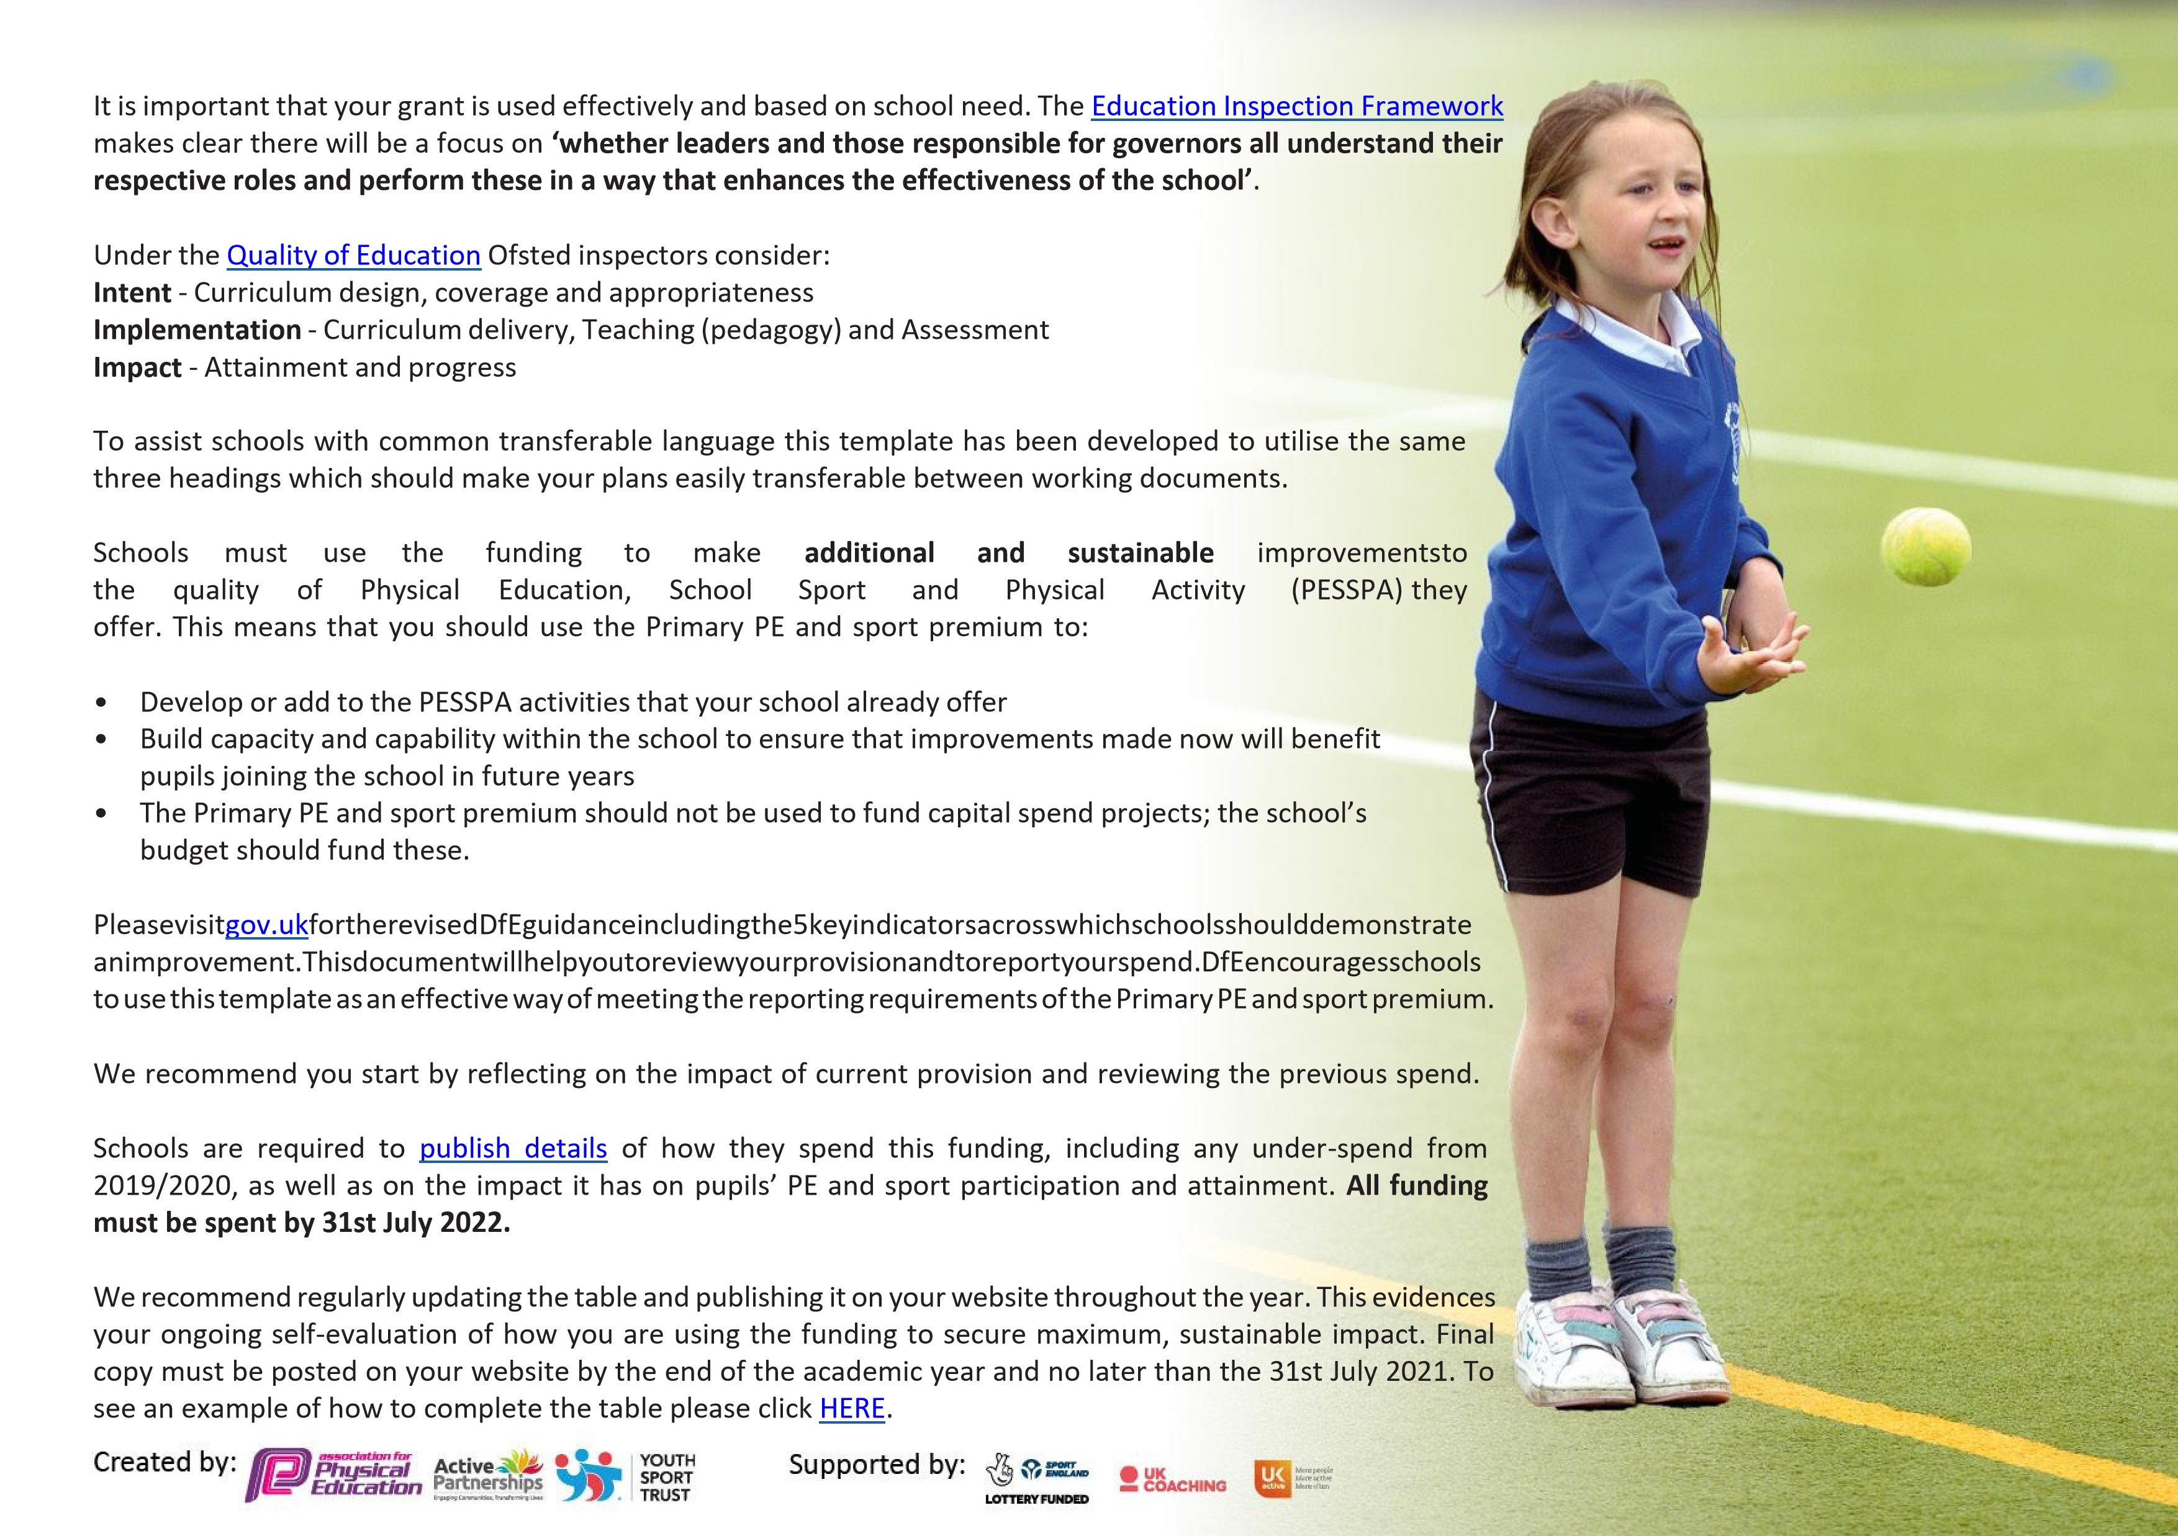


Details

with

regard

to

funding

Please

complete

the

table

below.

Swimming

Data

Please

report

on

your

Swimming

Data

below.

Total amount carried over from 2020/21 | £ 0
Total amount allocated for 2021/22 | £19,170
How much (if any) do you intend to carry over from this total fund into 2023/24 | £ 0
Total amount allocated for 2022/23 | £19,168
Total amount of funding for 2021/22. To be spent and reported on by 31st July 2022. | £ 19,168

Meeting national curriculum requirements for swimming and water safety.

N.B. Complete this section to your best ability. For example you might have practised safe self-rescue techniques on dry land which you can then transfer to the pool when school swimming restarts.
Due to exceptional circumstances priority should be given to ensuring that pupils can perform safe self rescue even if they do not fully meet the first two requirements of the NC programme of study
What percentage of your current Year 6 cohort swim competently, confidently and proficiently over a distance of at least 25 metres?  N.B. Even though your pupils may swim in another year please report on their attainment on leaving primary school at the end of the summer term 2020. Please see note above | 83%
What percentage of your current Year 6 cohort use a range of strokes effectively [for example, front crawl, backstroke and breaststroke]? Please see note above | 72%
What percentage of your current Year 6 cohort perform safe self-rescue in different water-based situations? | 83%
Schools can choose to use the Primary PE and sport premium to provide additional provision for swimming but this must be for activity over and above the national curriculum requirements. Have you used it in this way? | No
Action Plan and Budget Tracking
Capture your intended annual spend against the 5 key indicators. Clarify the success criteria and evidence of impact that you intend to measure to evaluate for pupils today and for the future.

Academic Year: 2022/23 | Total fund allocated: | Date Updated:
Key indicator 1: The engagement of all pupils in regular physical activity – Chief Medical Officers guidelines recommend that primary school pupils undertake at least 30 minutes of physical activity a day in school |  |  |  | Percentage of total allocation:
 |  |  |  | %
Intent | Implementation |  | Impact
Your school focus should be clear what you want the pupils to know and be able to do and about what they need to learn and to consolidate through practice: | Make sure your actions to achieve are linked to your intentions: | Funding  allocated  : | Evidence of impact: what do pupils now know and what can they now do?  What has changed?: | Sustainability and suggested next steps:
To engage more learners in active play and physical activity at break time and lunchtime. | Distribute more equipment from PE cupboard to be used at playtime and lunchtimes. | £250 | All children able to access a range of sport and play equipment to support active play. | Better quality resources to be purchased so equipment lasts  longer.  Children to be taught how to look after their equipment so it lasts longer.  Colour code equipment so year groups can be responsible for their own equipment
To increase the number of after school clubs and activities so more children can participate | Current after school clubs include:  Game Zone (Multi Sports)  CM Sports (Multi Sports) | £1500 | There wasn’t enough teacher intake so aren’t currently any after school sports clubs | Increase numbers and/or clubs on offer by asking for teacher/TA volunteers. Funding or partfunding providers in future as currently funded by parents
Intra year group competitions to be reintroduced and promotion of more unusual sporting competitions to encourage more children to feel confident in competing | Children from every class to participate in intra-year group competitions. | £500 | More children compete in competitive sport – more children might want to participate in afterschool clubs | PE lead to run the fixtures during lunch break to use the money on new equipment instead  Sporty and non-sporty pupils compete in competitive sport. Which will lead to motivate more pupils to signup to sport after school clubs.

‘Bounce to Birmingham’ to engage children in running a mile (daily) following success of Trek to Tokyo | Each class to complete a mile daily to see how many times we can run to  Birmingham and back (to celebrate  Commonwealth Games 2022) |  | More children | This didn’t happen so to think of new ways of introducing daily exercise or regular exercise into their day.
Key indicator 2: The profile of PESSPA being raised across the school as a tool for whole school improvement |  |  |  | Percentage of total allocation:
 |  |  |  | %
Intent | Implementation |  | Impact
Your school focus should be clear what you want the pupils to know and be able to do and about what they need to learn and to consolidate through practice: | Make sure your actions to achieve are linked to your intentions: | Funding  allocated  : | Evidence of impact: what do pupils now know and what can they now do?  What has changed?: | Sustainability and suggested next steps:
To promote healthy and active lifestyles | School life and science/pshe curriculum will promote physical exercise as part of a healthy and active lifestyle. | £ 750 | Children will have a good understanding of what a healthy and active lifestyle is and begin to  make personal choices to supplement this | Use our inspirational figures in the curriculum to model this –  survey children and parents to  understand lifestyles and attitudes to inside and outside of school
Increase levels of activity in wider curriculum | Teachers will plan for more active lessons (where appropriate) and introducing idea of ‘exercise snacks’ | £3200 | Learners will take part in more active lessons on a daily basis | For the children to have high quality teaching from both sports coaches and staff. For staff to become more confident with teaching PE because of staff insets provided by the local secondary school. Therefore the children’s self esteem will improve and they will develop a new positive attitude to trying new sports. This positivity from the pupils will lead the children to be successful at fixtures.
Improve the opportunities for pupils to develop understanding of other faiths and cultures to be prepared for life in modern Britain. | British sports stars who are from different cultures, faiths and backgrounds to be identified and displayed during new PE topics. | £0 | Raising awareness of British athletes and role models. | Role models to be explicitly identified on PE sports board

Celebrating participation in school sports and sports outside of school | Children celebrated in assembly, on our website and PE Wall of Fame |  | £100 | Children motivated to see their achievements celebrated and other children motivated to be celebrated | Have a sporting hero assembly once a term. In Summer term have a Sports Personality of the Year award assembly.
Key indicator 3: Increased confidence, knowledge and skills of all staff in teaching PE and sport |  |  |  |  | Percentage of total allocation:
 |  |  |  |  | 100%
Intent | Implementation |  |  | Impact
Your school focus should be clear | Make sure your actions to | Funding |  | Evidence of impact: what do | Sustainability and suggested
what you want the pupils to know | achieve are linked to your | allocated: |  | pupils now know and what | next steps:
and be able to do and about | intentions: |  |  | can they now do? What has
what they need to learn and to consolidate through practice: |  |  |  | changed?:
Support and training for all teachers so they are confident in delivering the PE curriculum to our children. | Purchase of the services of a PE provider who:  - Provides CPD for staff  - Specialist coaching across the academy  - Access to competing at a high levels in sports tournaments and competitions | £ 3,348 per month |  | Each teacher will benefit from working alongside a PE specialist for 1 hour per week  Children will have participated in sessions with specialised coaches preparing them for end of term tournaments | Move towards a service provider for the whole academy that includes planning, resources and sequenced progression to increase teacher confidence and development of skills.
PE Lead (along with external providers) to deliver CPD and staff training so staff feel more empowered to deliver the PE curriculum | Use Oakmoor Academy CPD  sessions  Use Chance 2 Shine CPD sessions | £500 |  | Staff feel more empowered and confident to deliver good quality  PE learning | Make attendance at least one PE CPD session compulsory  for all staff  For staff to attend the Oakmoor PE inset training day
Key indicator 4: Broader experience of a range of sports and activities offered to all pupils |  |  |  |  | Percentage of total allocation:
Intent | Implementation |  |  | Impact
Your school focus should be clear | Make sure your actions to | Funding |  | Evidence of impact: what do | Sustainability and suggested

what you want the pupils to know | achieve are linked to your | allocated: | pupils now know and what | next steps:
and be able to do and about | intentions: |  | can they now do? What has
what they need to learn and to consolidate through practice: |  |  | changed?:
Ensure the PE curriculum is broad and allows our learners an ‘experience-rich’ curriculum | PE lead to continue developing curriculum to diversify range of sports we teach including table tennis, handball, blind football, indoor curling & flag football | £2000 | Children across the school have access to a broader range of sporting experiences in their PE lessons | PE lead to use funding next year to buy equipment that allows children to experience different sports (volleyball, sit down volleyball)
Try to take our children to live sporting experiences (Euro Women’s 2022 football tournament) or provide outside specialist coaching (Chelsea  FC, Game Zone) | PE lead to continue to develop networks and links with outside  agencies to explore these different  opportunities | £500 | Children will experience something completely different that broadens and riches their cultural experiences | Monitor feedback of experiences and impact it has  on the learners
Target some after school clubs at specific groups | PE lead to liaise with staff about offering some targeted after school clubs:  - Girls only  - PP  - Reluctant PE | £500 | PE and sport to be inclusive for all children | Survey children from these targets groups pre and post clubs to monitor the impact and next steps to be taken
Key indicator 5: Increased participation in competitive sport |  |  |  | Percentage of total allocation:
 |  |  |  | %
Intent | Implementation |  | Impact
Your school focus should be clear | Make sure your actions to | Funding | Evidence of impact: what do | Sustainability and suggested
what you want the pupils to know | achieve are linked to your | allocated: | pupils now know and what | next steps:
and be able to do and about | intentions: |  | can they now do? What has
what they need to learn and to consolidate through practice: |  |  | changed?:
Interschool tournaments between local cluster schools to focus on more unusual sporting events and can be offered to a wider range of children | Children to be targeted at these events to ensure a wide and broad  range of participants | £300 | More children inspired to take part in competitive sport and represent the school as not the same children picked all the time | Survey children to ascertain reasons for and against participating in these events

Signed off by
Head Teacher: | C.James
Date: | 05.09.23
Subject Leader: | Cherie Nijhuis
Date: | 05.09.23
Governor: | Penny Flux
Date: | 05.09.23

